User manual

Introduction:

Link to code : https://github.com/u20772077/BUDDY-NLP-AND-LEARNING-PLATFORM

Buddy is a simple Natural Language processing and educational system designed at the moment to assist students ( More specific – high school level ) during the learning process. It works by dividing a topic of interest into small chunks for analyses and display to a user.

The key objective remains the same. Its primary goal or objective is to give users LONG term feedbacks by using a distribution of answers during QnAs provided by the user and take a representative value to represent them. This value is then compared with threshold value for final conclusions.

##### No login required.

Two main Buttons are of importance in the system. Button 1 “File” takes you to learning domain which has view similar to NLP window and communication. Five randomly selected questions are selected from database for display.

To attempt a question : first Enter the question number which appear as the first string on the data like this ….(03 [SPACE] QUESTION). Once you have enter the question number then enter space then followed by your answer. If this procedure not followed properly. The system will display “ incorrect answers for correct inputs “ . This is because it was designed to skip two characters in a sentence [ 2: ] to evaluate the answer. The system will then display an answer on your window, then prompt for more inputs.

Picture 1: Learning and Testing platform.

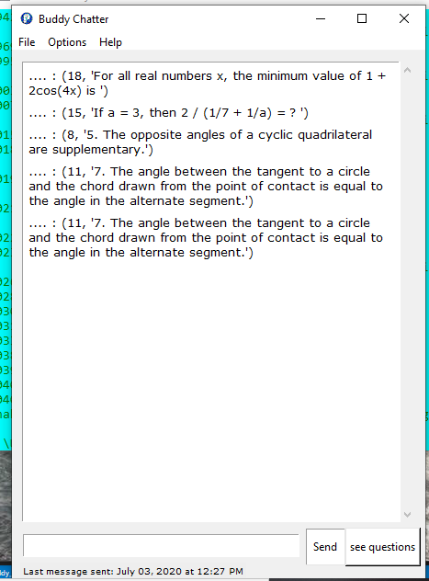

To use the chat environment . Simply type your question with enough informative words e,g “ Define Tan chord theorem” . The key word being Tan, Chord , and or Theorem. To access sequential information type eg “ line1 tan chord theorem” To access the first line of the tan chord theorem proof.

Picture 2 : Chat environment.

